Aim: To develop a Mini E-Commerce Progressive Web App (PWA) using HTML, CSS, JavaScript, Manifest File, and Service Worker.

Theory:

Q1. What is a Progressive Web Application (PWA)?
A PWA is a web app that uses modern browser capabilities to deliver an app-like experience (offline support, push notifications, home screen installation) without requiring an app store.

Q2. What are the key features of PWAs?
- Installable (add to home screen)
- Offline capable
- Reloads quickly
- Secure (HTTPS)
- Responsive design
- Push notifications
- App-like navigation

Q3. What is a Manifest File?
A JSON file (manifest.json) that provides app metadata (name, icons, theme colors, start URL) to enable installation and home screen launch.

Q4. What is a Service Worker?
A JavaScript file that runs in the background, intercepting network requests, caching resources, enabling offline functionality and push notifications.

Q5. Why is HTTPS required for PWAs?
Service workers can modify network responses, so HTTPS ensures the service worker is not tampered with (prevents man-in-the-middle attacks). Localhost is an exception for development.

Q6. Explain the structure of a PWA project.
project/
├── index.html
├── manifest.json
├── service-worker.js
├── style.css
└── assets/
├── icons/
├── images/
├── videos/
└── svgs/
Q7. To design and implement a Mini E-Commerce PWA and observe its behavior.
Code (index.html):
<!doctype html>
<html lang="en">
<head>
<meta charset="UTF-8" />
<meta
name="viewport"
content="width=device-width, initial-scale=1.0, viewport-fit=cover"
/>
<meta name="theme-color" content="#4CAF50" />
<title>DAWG | PWA</title>
<link rel="stylesheet" href="styles.css" />
<link rel="manifest" href="manifest.json" />
<link rel="apple-touch-icon" href="icons/icon-192.png" />
<meta name="apple-mobile-web-app-capable" content="yes" />
<meta
name="apple-mobile-web-app-status-bar-style"
content="black-translucent"
/>
</head>
<body>
<header>
<h1>DAWG</h1>
<div style="display: flex; gap: 15px; align-items: center">
<button id="theme-toggle">
<span id="theme-icon">🌙</span>
</button>
<div class="cart-icon">🛒 <span id="cart-count">0</span></div>
</div>
</header>

<main>
<div class="products-grid" id="products-grid"></div>
</main>

<div class="cart-modal" id="cart-modal">
<div class="cart-modal-content">
<span class="close">&times;</span>
<h2>Your Cart</h2>
<div id="cart-items"></div>
<div class="cart-total">
<strong>Total: ₹<span id="cart-total">0</span></strong>
</div>
<button id="checkout-btn" class="checkout-btn">Checkout</button>
</div>
</div>

<div class="install-prompt" id="install-prompt" style="display: none">
<p>Install this app on your device</p>
<button id="install-btn">Install</button>
<button id="close-install">✖</button>
</div>

<script src="app.js"></script>
</body>
</html>

Code (service-worker.js):
const CACHE_NAME = "ecommerce-pwa-v1";
const ASSETS_TO_CACHE = [
"/",
"/index.html",
"/styles.css",
"/app.js",
"/manifest.json",
"/icons/icon-192.png",
"/icons/icon-512.png",
];

self.addEventListener("install", (event) => {
event.waitUntil(
caches
.open(CACHE_NAME)
.then((cache) => {
console.log("Caching assets");
return cache.addAll(ASSETS_TO_CACHE);
})
.then(() => self.skipWaiting()),
);
});

self.addEventListener("activate", (event) => {
event.waitUntil(
caches
.keys()
.then((cacheNames) => {
return Promise.all(
cacheNames.map((cacheName) => {
if (cacheName !== CACHE_NAME) {
console.log("Deleting old cache:", cacheName);
return caches.delete(cacheName);
}
}),
);
})
.then(() => self.clients.claim()),
);
});

self.addEventListener("fetch", (event) => {
event.respondWith(
caches.match(event.request).then((cachedResponse) => {
if (cachedResponse) {
return cachedResponse;
}
return fetch(event.request)
.then((response) => {
if (!event.request.url.startsWith(self.location.origin)) {
return response;
}
if (event.request.method !== "GET") {
return response;
}

return caches.open(CACHE_NAME).then((cache) => {
cache.put(event.request, response.clone());
return response;
});
})
.catch(() => {
if (
event.request.headers
.get("accept")
.includes("text/html")
) {
return caches.match("/index.html");
}
return new Response("Offline - content not available");
});
}),
);
});

Code (manifest.json):
{
"name": "DAWG",
"short_name": "DAWG",
"description": "A mini e-commerce progressive web app",
"start_url": "/",
"display": "standalone",
"theme_color": "#4CAF50",
"background_color": "#ffffff",
"orientation": "portrait",
"icons": [
{
"src": "icons/icon_96px.png",
"sizes": "96x96",
"type": "image/png",
"purpose": "any maskable"
},
{
"src": "icons/icon_128px.png",
"sizes": "128x128",
"type": "image/png"
},
{
"src": "icons/icon_256px.png",
"sizes": "256x256",
"type": "image/png"
},
{
"src": "icons/icon_512px.png",
"sizes": "512x512",
"type": "image/png"
}
]
}

Code (app.js):
const products = [
{
id: 1,
name: "Resident Evil 7",
price: 1499,
poster: "https://image.api.playstation.com/vulcan/ap/rnd/202206/0207/V6IViuKogBMRtajqjnYrcj0e.png",
category: "horror",
},
{
id: 2,
name: "Resident Evil 8",
price: 1999,
poster: "https://image.api.playstation.com/vulcan/ap/rnd/202101/0812/FkzwjnJknkrFlozkTdeQBMub.png",
category: "horror",
},
{
id: 3,
name: "Resident Evil 9",
price: 2499,
poster: "https://image.api.playstation.com/vulcan/ap/rnd/202512/1205/79661d7a2bdb9784749b4e57e1456ca89f7ac7bed8615aee.png",
category: "horror",
},

{
id: 7,
name: "GTA V",
price: 1499,
poster: "https://image.api.playstation.com/vulcan/ap/rnd/202202/2816/K6mmm89oNII1iI1aqaClO0wh.png",
category: "action",
},
{
id: 8,
name: "Red Dead Redemption 2",
price: 1999,
poster: "https://image.api.playstation.com/gs2-sec/appkgo/prod/CUSA08519_00/12/i_3da1cf7c41dc7652f9b639e1680d96436773658668c7dc3930c441291095713b/i/icon0.png",
category: "action",
},
{
id: 9,
name: "DOOM 2016",
price: 999,
poster: "https://image.api.playstation.com/vulcan/ap/rnd/202009/2814/GGyEnCkIXoyiVlN9sRHkzUPo.png",
category: "shooter",
},
{
id: 16,
name: "DOOM Eternal",
price: 1999,
poster: "https://image.api.playstation.com/vulcan/ap/rnd/202010/0114/ERNPc4gFqeRDG1tYQIfOKQtM.png",
category: "shooter",
},
{
id: 10,
name: "Ghost of Tsushima",
price: 2499,
poster: "https://image.api.playstation.com/vulcan/ap/rnd/202010/0222/niMUubpU9y1PxNvYmDfb8QFD.png",
category: "action",
},
{
id: 11,
name: "Ghost of Yotei",
price: 2999,
poster: "https://image.api.playstation.com/vulcan/ap/rnd/202504/2116/050bb77f895515e0b0e906b0b9d75b6174b37eece097b462.png",
category: "action",
},
{
id: 12,
name: "Horizon Zero Dawn",
price: 1499,
poster: "https://image.api.playstation.com/vulcan/ap/rnd/202010/0221/vC7trMorHJgbImp8PCQvpI0p.png",
category: "rpg",
},
{
id: 13,
name: "Horizon Forbidden West",
price: 2499,
poster: "https://image.api.playstation.com/vulcan/ap/rnd/202010/2915/kifM3lnke5lExwRd96mIDojQ.png",
category: "rpg",
},
{
id: 14,
name: "Outlast Trials",
price: 1199,
poster: "https://image.api.playstation.com/vulcan/ap/rnd/202603/1014/686d2f759e42d2a5b85140203dcf3e439b37ff6244b9ce23.png",
category: "horror",
},
{
id: 15,
name: "Outlast 2",
price: 1099,
poster: "https://image.api.playstation.com/gs2-sec/appkgo/prod/CUSA06633_00/3/i_d608871643e7c4aa9b73ee8114ae527eff3548be4ac24e0053e3ceed1b903ff0/i/icon0.png",
category: "horror",
},
{
id: 4,
name: "Black Ops 3",
price: 999,
poster: "https://image.api.playstation.com/gs2-sec/appkgo/prod/CUSA02624_00/6/i_c215706b64aaf3a61d26f8496a19ff5e4151fa30f504c8510ff66c7561965ec3/i/icon0.png",
category: "shooter",
},
{
id: 5,
name: "Modern Warfare 2019",
price: 1299,
poster: "https://image.api.playstation.com/vulcan/ap/rnd/202212/1917/OS18LBxAVpQ1iPeGWAqSnxem.png",
category: "shooter",
},
{
id: 6,
name: "Modern Warfare 2022",
price: 1799,
poster: "https://image.api.playstation.com/vulcan/ap/rnd/202205/2800/W5uSEsW7yefCNTHatS03v5q7.png",
category: "shooter",
},
];

window.addEventListener("beforeinstallprompt", (e) => {
e.preventDefault();
deferredPrompt = e;
const installPrompt = document.getElementById("install-prompt");
if (installPrompt) installPrompt.style.display = "flex";

document
.getElementById("install-btn")
?.addEventListener("click", async () => {
if (deferredPrompt) {
deferredPrompt.prompt();
const { outcome } = await deferredPrompt.userChoice;
if (outcome === "accepted") {
console.log("User accepted install");
}
deferredPrompt = null;
installPrompt.style.display = "none";
}
});

document.getElementById("close-install")?.addEventListener("click", () => {
installPrompt.style.display = "none";
});
});

function initOfflineDetection() {
function updateOfflineStatus() {
if (!navigator.onLine) {
let indicator = document.getElementById("offline-indicator");
if (!indicator) {
indicator = document.createElement("div");
indicator.id = "offline-indicator";
indicator.className = "offline-indicator";
indicator.innerHTML =
"⚠️ You are offline. Games will be available from cache.";
document.body.insertBefore(indicator, document.body.firstChild);
}
} else {
const indicator = document.getElementById("offline-indicator");
if (indicator) indicator.remove();
}
}

window.addEventListener("online", updateOfflineStatus);
window.addEventListener("offline", updateOfflineStatus);
updateOfflineStatus();
}

if ("serviceWorker" in navigator) {
window.addEventListener("load", () => {
navigator.serviceWorker
.register("/service-worker.js")
.then((reg) => console.log("Service Worker registered:", reg))
.catch((err) =>
console.log("Service Worker registration failed:", err),
);
});
}

function addToCart(product) {
const existing = cart.find((item) => item.id === product.id);
if (existing) {
existing.quantity++;
} else {
cart.push({ ...product, quantity: 1 });
}
saveCart();
showToast(`🎮 Added ${product.name} to cart!`);
}
Output:

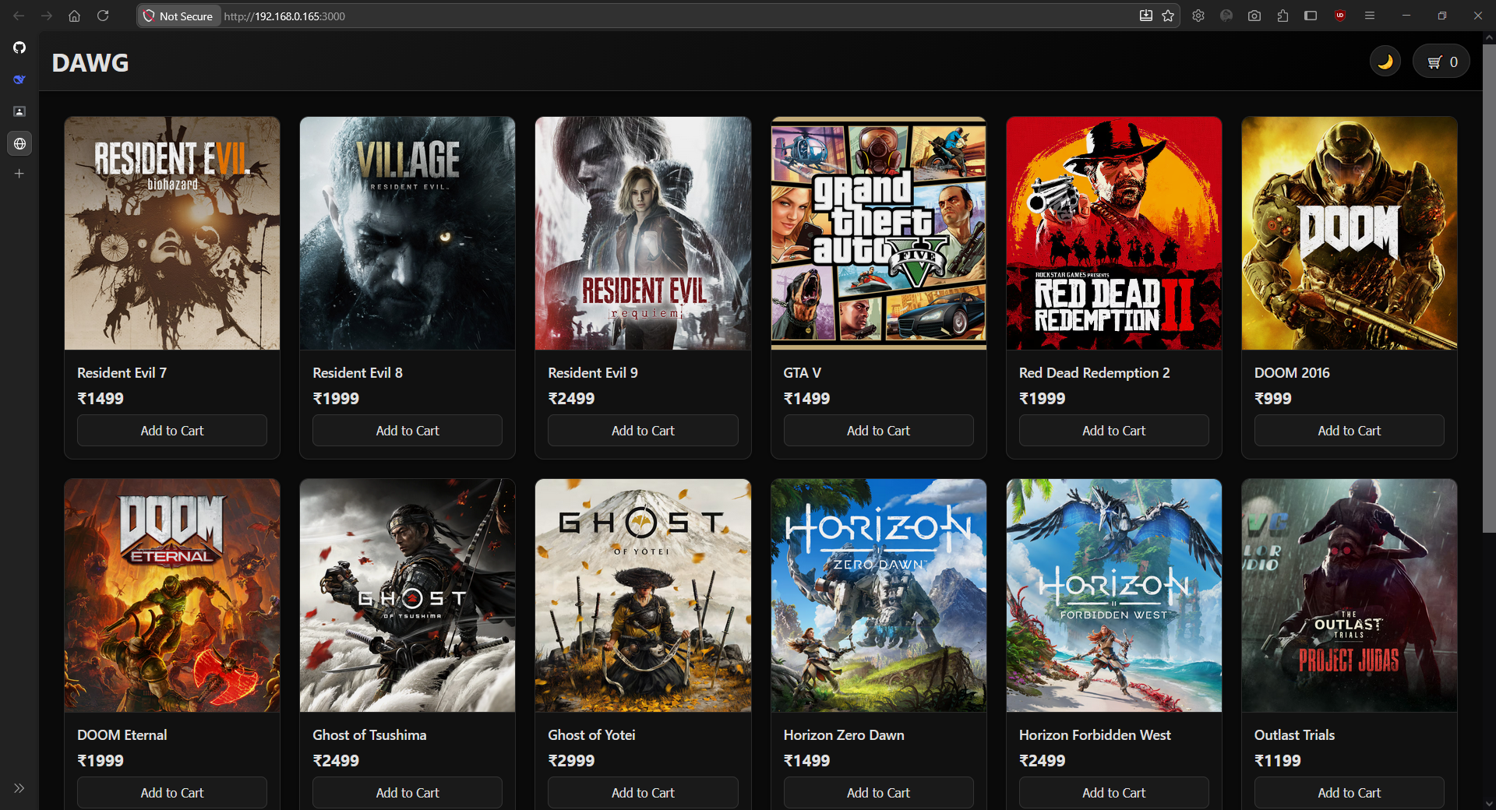

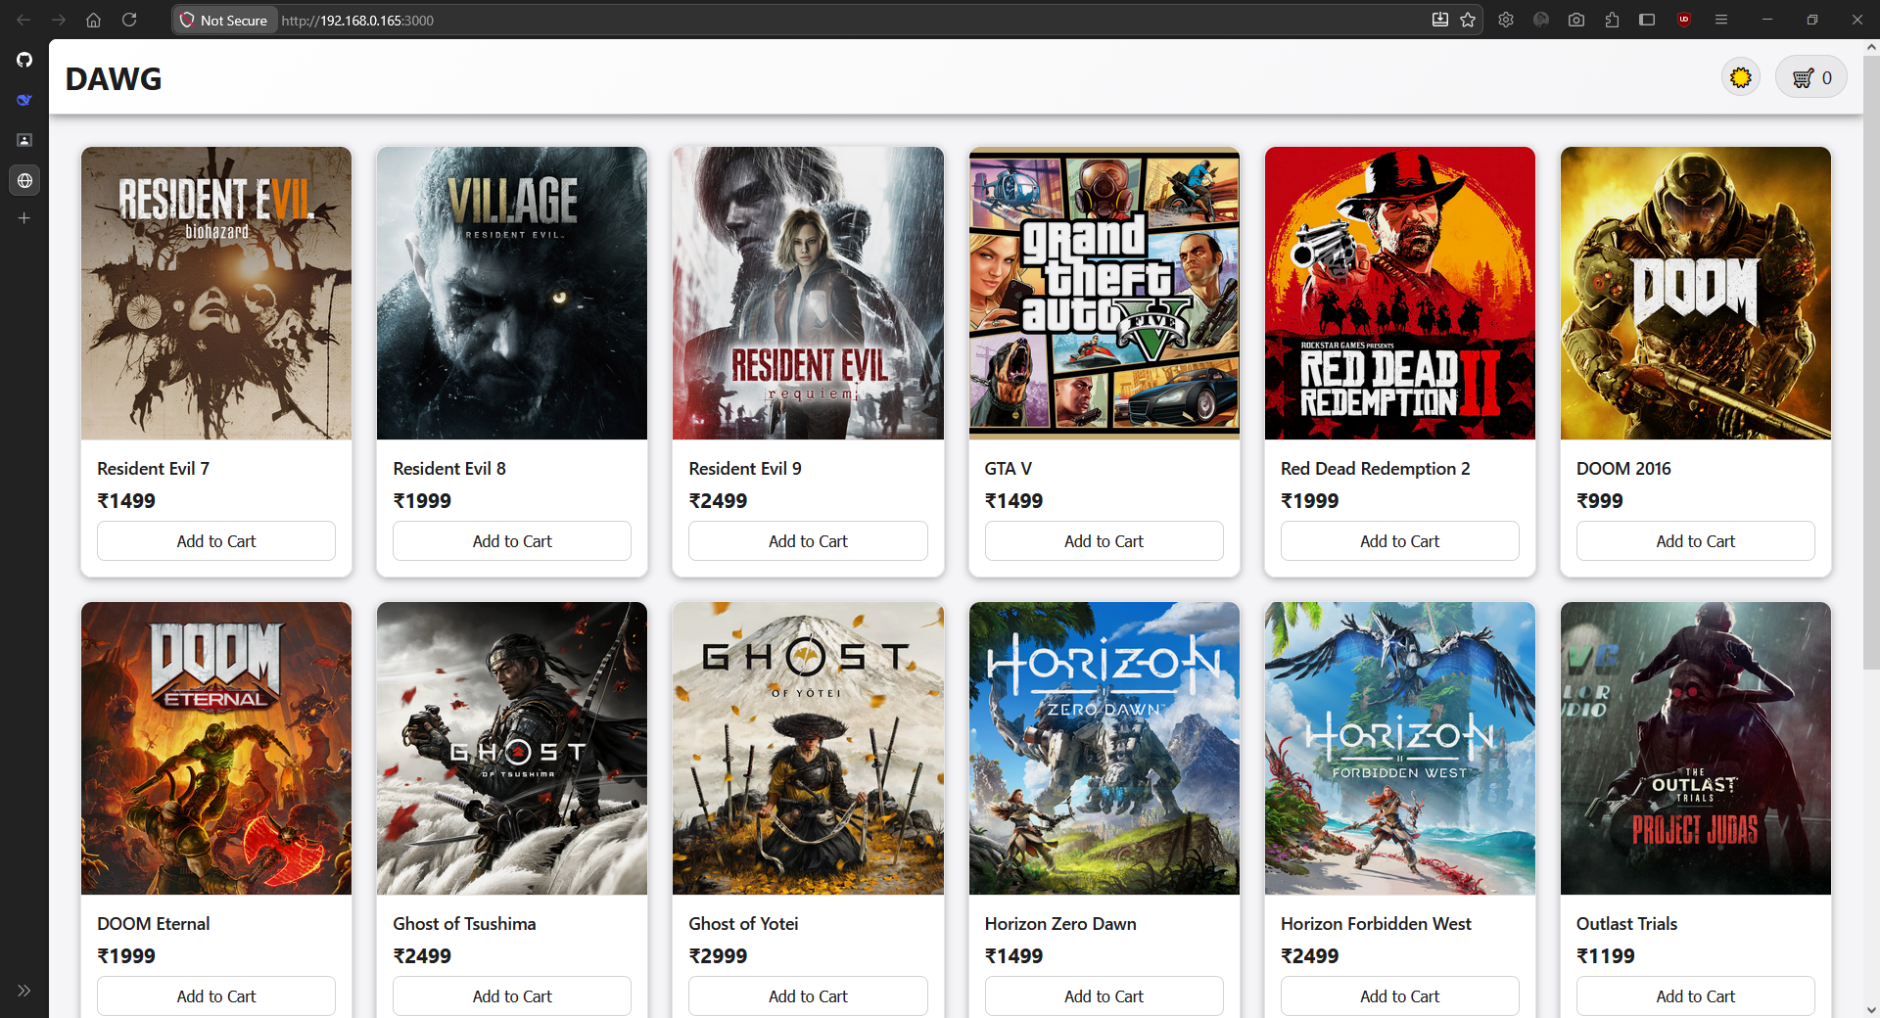

Installed to the system:
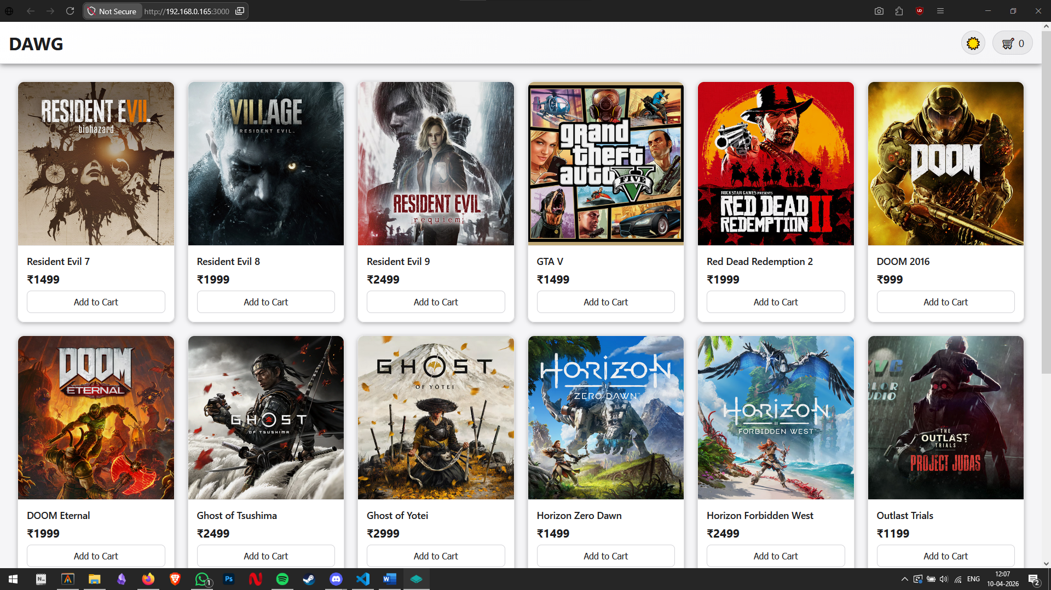

Cart:
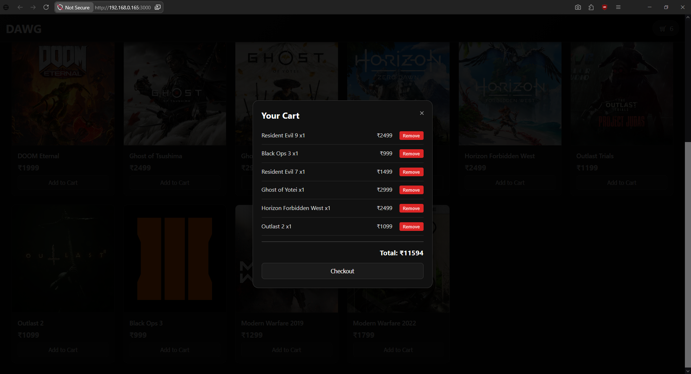

Conclusion
Successfully developed a Mini E-Commerce Progressive Web App (PWA) using HTML, CSS, JavaScript, Manifest File, and Service Worker.

